IRIN ANN VARUGHESE
Mobile:7539914956
Email: irinavr1997@gmail.com
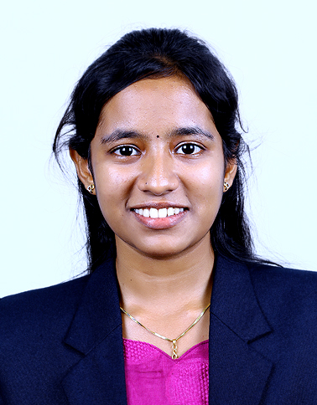

CAREER OBJECTIVE
.
To secure a challenging position in a reputable organization to expand my learning’s, knowledge, and skills, also to secure a responsible career opportunity to fully utilize my training and skills, while making a significant contribution to the success of the company.

ACADEMIC QUALIFICATION
Degree/ Course | Institution | University / Board | Year of Passing | CGPA/ % of Marks
B.TECH/  BIOTECHNOLOGY | Karunya Institute of Technology and Sciences | Deemed University | 2020 | 7.89
XII | Mar Dionysius senior secondary school Rishi valley, Mallappally | CBSE | 2016 | 70
X | Mar Dionysius senior  secondary school Rishy valley, Mallappally | CBSE | 2014 | 8.8

* CGPA out of 10.

AREA OF INTEREST

- Industrial biotechnology
- Drug design and development
- Reactor designing
- Marketing and transportation

COURSE CERTIFICATE

Successfully completed Drug Commercialization, an online non credit course authorized by University of California San Diego offered through Coursera

PROJECT DETAILS

Completed project on DESIGN, FABRICATION AND STUDY ON MICROBIAL FUEL CELL USING COW MANURE FOR BIOELECTRICITY GENERATION by june 2020 under the supervision of Dr R S David Paul Raj assistant professor, department of biotechnology at Karunya Institute of Technology and Sciences.

ACHIEVMENTS
.
- Attended National Level technical symposium on innovations in biotechnology for sustainable development- clean and green technology organized by Karunya Institute of technology and sciences in 2016

- Participated in International conference on emerging synergies in agriculture,food processing engineering and biotechnology at Karunya institute in 2018

- Presented poster entitled manipulating technology for surplus extraction in National level technical symposium evogen organized by Karunya Institute of technology and sciences in 2018.

- Poster presentation entitled scombroid fish poisoning factors in the National symposium on Bio-prospecting from marine resources for biotechnology applications in Sathyabama Insitute of technology and sciences in 2019.

- Poster presentation on design, fabrication and comparison study on MFC using cow manure, waste water and benthic mud for bioelectricity generation in the International conference on recent biotechnology innovation in agriculture in 2020.

- Proposal on behalf of department from Harvard University funded projects

TRAINING DETAILS

Name of the Industry | Duration | Areas of Exposure
Pasteur institute of central government, Coonoor  Amul plant, Gujarat | 5 Days  15 Days | Vaccine production  Milk manufacturing for different products and transportation
LEADERSHIP SKILLS

- Active participation in college activities

- Team member of students workshop
- Organized various functions and conferences at college

STRENGTHS
- Self Motivated.
- Quick Learner and Team player.
- Flexible and hard worker, Leadership, positive attitude

HOBBIES

- Learning new things.
- Batminton player
- Listening to Music and drawing

PERSONAL PROFILE

Father’s Name : P.V VARUGHESE
Date of Birth : 08.11.1997
Gender : Female
Marital status : Single
Languages Known : Malayalam, English Nationality. : Indian

DECLARATION
.
I am keen to continue my career and prepared to work hard in order to achieve my organization objectives andI hereby declare that the information furnished above is true to the best of my knowledge.

Place: MALLAPPALLY, PATHANAMTHITTA , KERALA

Date:21/03/2021 (IRIN ANN VARUGHESE)

